Paul Nichols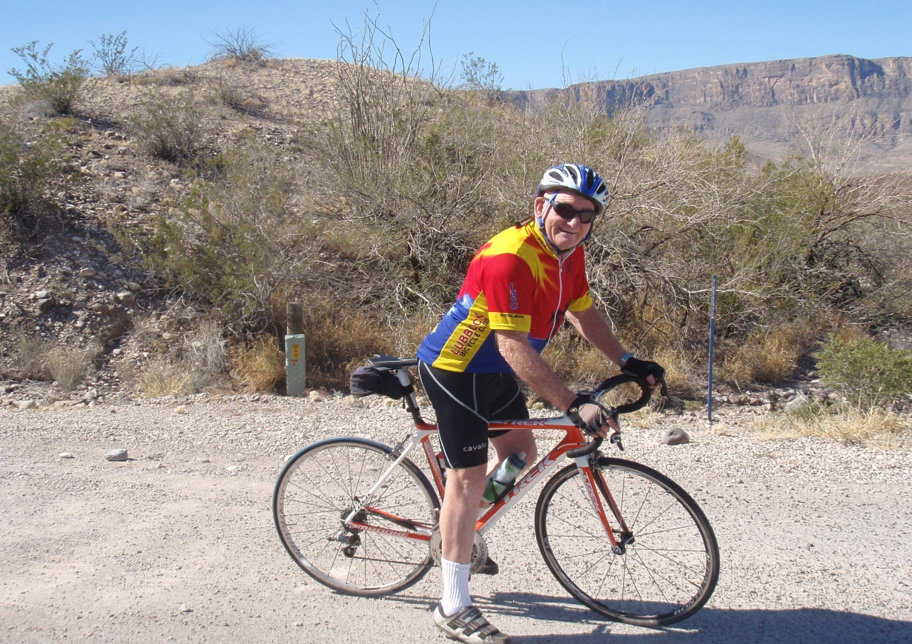
“Bring on them young bucks”

Memories from friends
Paul’s motto, "Bring on them young bucks". Paul liked nothing more than to sprint past a younger biker and show them that he still had his speed. He was an inspiration to us younger guys even though we cursed him when he flew past us.
Paul bought his new bike in Dallas and asked the bike shop manager to have the front oversized road gear from his old bike installed on the new bike. He overheard the young mechanic in back of the shop yell “WHAT”!!! there aint nobody around here that can turn this big sucker! Paul, in his cowboy hat and boots hollered around the corner, "This Old Man Can"! And he could, he damn sure could.
We will miss him so.

Hotter N Hell 100 2010, Not necessary my favorite Paul memory, but definitely my most "memorable". After another crash that landed him in the hospital with stiches and bruises and a lump on the head, In the emergency room at Wichita Falls with Paul. I said Paul, have you called your wife. He said nope, not yet!!! I don’t really think he wanted to call Judy and explain he had been in a wreck, especially after she encouraged him to not go. I told Paul I was going to call Judy and let her know the situation. He reluctantly agreed to and gave me permission to call Suzette and Judy.

Now the funny part! First, the Doc thought Paul had heart problems because his heart rate was so slow! Paul finally made them understand that he wasn’t normal! He was a finely tuned athlete with a slow pulse because he was in incredible shape, but 70 years old!

The next funny thing was when the doctor came in and told Paul that if he couldn’t remember the accident that he would need to stay overnight, Paul immediately said "doc" it’s all coming back to me!. Yes, I lost control of my bike and went into the bar ditch and when coming back on to the road, my tire caught the edge and threw me off on the asphalt, bumped my head, yep that’s how it happened!, now get me the heck out of here. Paul stayed the night!
Scott Wade

Paul was a beast on that bike! I will never forget the first time I rode with
the group...we rode about 30 miles. I couldn't believe how helpful he was on the ride, he rode up beside me when I was falling behind and said in a demanding voice "boy, if you switch them gears right you'll be able to keep up". That was the last time I saw him that day!! The next few times I rode I marveled at how a man that was obviously much older than everyone was considerably stronger than everyone. I typically saw him only in the beginning of the rides. His love of the sport was infectious for me as I have continued to ride and grown to love it. Whenever I would see Paul at a game or around town the conversation always end up on cycling. He wanted to make sure I was still riding and always encouraged me to keep it up. I will miss seeing him out there and miss our conversations. My only hope is that one day I will learn how to switch them gears and not fall behind!
Keep on pulling!!!

Lewis Hill

In 2006 I was new to Lubbock. I had done virtually no riding and
started coming out for the Tue and Thu evening rides. I moved to Lubbock from Alaska. I think I remember one ride when it was around 103, but most all those summer rides were hot. I am younger and slower than Paul. When I pulled into the truck stop it was always great to see the people milling around Paul's truck and the cooler full of Gatorade.

Paul was a wonderful wonderful person - the type of human that makes
cycling so rewarding. I camped with the club and Paul one year at Ft
Davis and Big Bend - those are great memories.

I will always consider myself blessed and honored to have known and
ridden with Paul. Tim Vignos - Eugene OR

The funniest thing I saw Paul do was on the Big Bend ride on March 2nd. He was changing his jersey and flexed for a picture – a classic muscle-builder pose with a huge smile – his expression was hilarious, and I only wish that I can look that good when I’m 72!
Derek Oler
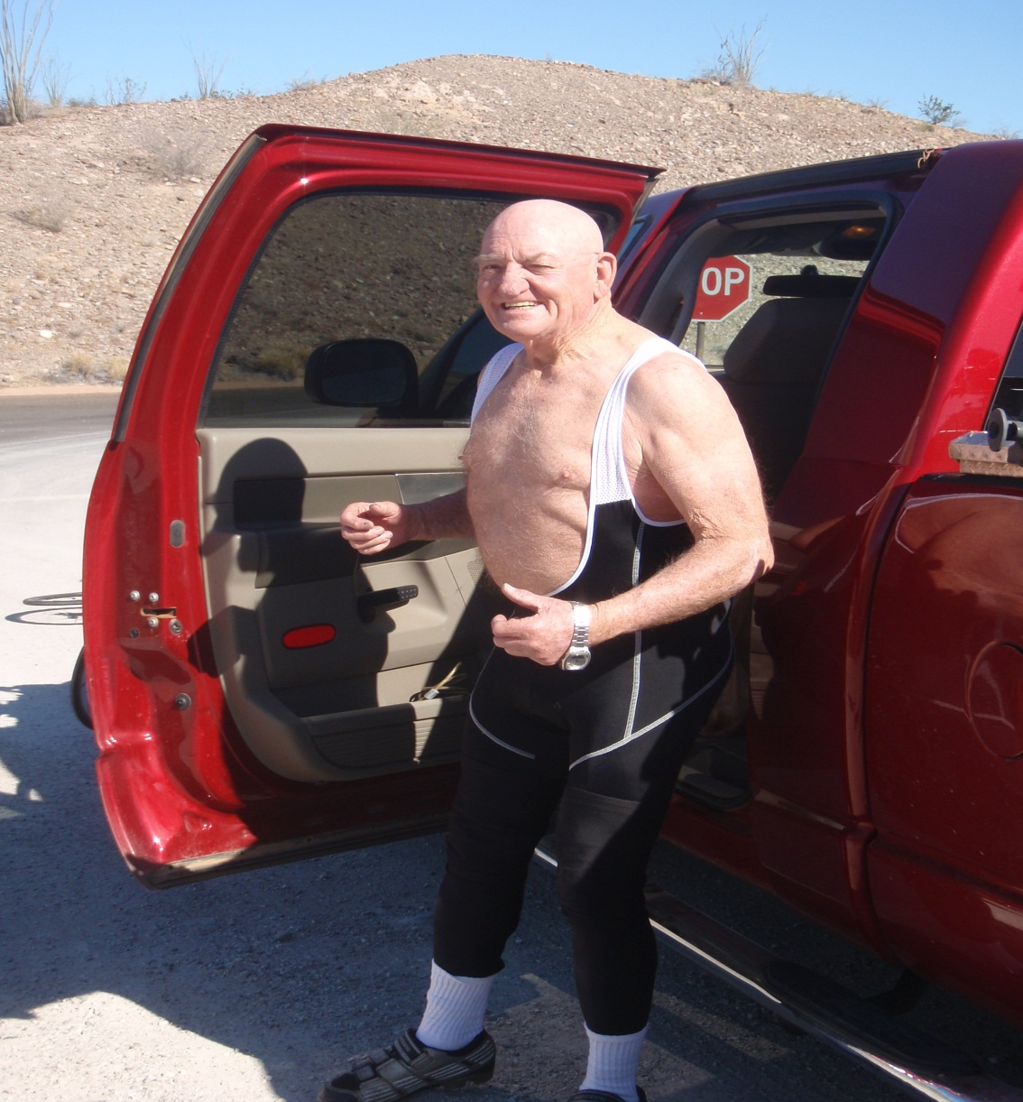

“Tour De Paul” Levelland friends organized a 70 mile ride for Paul on his 70th birthday, "Tour De Paul" 70 @ 70. Many of his friends from the South Plains Area came and rode even though it was 104 F outside. Thinking that everyone would be watching him finish because he heard me call my wife to tell her “we are coming in from ¼ mile out and Paul is with us”, Paul sprinted across the 70 mile finish in style only to cramp up and land upside down 200 yards down the road, he couldn’t get out of his pedals due to the cramps. His brother Charlie had to go down and pick him up off of the street. Everyone had remained in the building in front of the fans because it was too dang hot outside, and my wife didn’t get the hint to have everyone come out to cheer. Only a few witnessed the tumble. Bill Ritchie even wrote a song about Paul for his 70th, it was great. Paul quoted that it was the best birthday that he had ever had. A short time later, Paul crashed into Bill when he was distracted by a young pretty reporter in a mini skirt doing an interview near the roads edge. Bills back wheel was destroyed, Paul’s titanium knees were unharmed! He was probably doing the muscle man pose there too Derekl!

To me, Paul was a character straight out of Lonesome Dove, but on a bicycle
instead of a horse. He was everything right and kind even though he would tell
you that he had been a little honery a time or two himself, or three, maybe
four!

Buddy Hutto

I rode quite a bit with Paul back in the 90’s, mostly club rides. For a good while Paul was a regular for George Canon’s Wednesday “Metro Hills” ride that left from 4th and Toledo and went through the Canyon Lakes, out to the airport, FM 2641 and back to 4th via Quaker Ave.
I wish I could remember the details of the time he and his buddy had ridden up to the top of Sierra Blanca, and somewhere along the descent his handlebars came off! I laughed till I cried listening to Paul tell that one.
I remember Paul telling about the time he pulled his old pickup into a now defunct bike shop on 34th. He got out of his truck, wearing his work clothes – cowboy hat and boots, jeans, western shirt… you know Paul. He went inside and despite a “what the hell are you doing in here” look from the shop guy, Paul says “I’m interested in one of them thar road bikes.” The guy is understandably very dubious, but Paul persists. “How ‘bout this un, I’d like to take her out for a spin.” Reluctantly the shop guy pulls the bike out and watches as Paul mounts up, still in his hat and boots, and heads off down the street, the shop guy is in shock! As I recall, Paul didn’t buy that bike. In defense of the “shop guy” there are folks who look like they might be bike riders and there are folks who don’t, but Paul proved looks can be very deceptive!
As I write this, I realize the story is in the telling, and nobody could tell a story like Paul. I am greatly saddened that he’s no longer with us, but glad that he died doing what he loved. I miss him.
Ken Spain

I am so heartbroken over this incident that words cannot describe it. I only knew Paul for the last three years but he had forever found a place in my heart. Trying to come up with a favorite memory is tough as there are so many wonderful times we spent together logging miles on our bicycles. I first met Paul at his 70th birthday ride, Tour de Paul. Susan introduced me to him and he told me I had a beautiful wife. From that day forward, he always referred to her as my “beautiful bride”. When Susan couldn’t make a Tuesday/Thursday ride, he made sure I brought her home a red PowerAde drink. While this memory is not one that makes you laugh hysterically, it really showed his compassionate caring side. I will miss him very much.
Brian Alger
We spent a great weekend with Paul in big bend last weekend! We went to the hot springs with him and he entertained us with his crash stories. We had a hard time getting him out of there (especially when the lady with the bikini showed up!)
Nancy Hepburn

My son Xander and I have been riding with Paul and WTCA since he was 9; he's now 17.

I don't remember exactly when Paul first started mentoring Xander as a rider -- probably when I started letting go enough that I could deal with letting him ride more than a few feet away from me... I remember Paul and Xander challenging each other on the Sunday rides...early on Paul obviously not having much trouble keeping ahead of Xander if he wanted to, but always riding hard enough to spark Xander's competitive side. The ride I remember the most was one of the Tues/Thurs rides out in the canyons east of Lubbock, when Xander took off with Paul, and for the first time, he (Xander) managed to finish the ride ahead of me. All of a sudden, cycling became something different for Xander. It was no longer just something he did with dad, dawdling along at the back of the pack, but something he was good at, that he wanted to excel at. Paul had turned riding from a family chore into an exciting new adventure.

Xander has long since left me in the dust, and even Paul in the last year or so. I haven't seen much besides his back wheel for a long time. But while Xander would probably rather have teeth pulled than ride with his dad, riding with Paul was a different thing altogether. That was never a chore, always a pleasure, and always a challenge for the sprint at the end.

Paul was a great rider; he was competitive, he loved the sprint at the end, leaving us 50+ -year-old youngsters behind at the end of the ride. But his heart was bigger than his ego when it came to riding -- with all of us, not just -- with Xander. Instead it was all about making it both fun and challenging enough that everyone ended up smiling, no matter who finished first at the end.

In fond memory of Paul Nichols.

Ian, Scott-Fleming

I had the good fortune of riding with Paul to several biking events over the years. He was so quick to offer his pick-up to haul camping supplies, people, and bikes to club events. And the help didn't stop there. He could be counted on to assist with every aspect of the ride, from sag, to setting up camps, loading and unloading bikes, to helping with food prep and even the cleanup. He never 'sandbagged' on any of it! Which is what led him to get into a confrontation with a javelina about 4 years ago in Big Bend National Park. Paul had disposed of some leftover spaghetti water next to a tree. Not too long after that, we were all aroused from our reveries and stories around the campfire to snorting, stomping and a general ruckus in that vicinity: Paul versus javelina. And who won? Paul, of course. The peccary turned tail and disappeared into the night, and our camp was saved from the intrusion.
Also, Paul was such a considerate traveling companion. He always graciously indulged my Sonic habit without any complaints, even if he was dragging a trailer.

I am sure that day by day, memory by memory, we will all discover the many ways that we miss Paul.
Liza Muse
Scott Wade introduced me to Paul at lunch somewhere in Levelland – I think a few weeks prior to the Tour de Paul. I thought, man that is really cool – a 70 mile ride at 70 years old. Hope I will be able do that some day. Then, a couple of years ago, I went on a small group ride with some of you guys, which turned out to be my only ride with Paul.
It was a hot, breezy, mid-week late afternoon in Levelland. Typical summer time weather, and Paul was being overly modest about his new carbon Trek. We left out from the parking lot at SPC, and headed out against the wind going somewhere south of Levelland. After 25 miles or so, on the way back into town, we rode down into a depression that was probably an old playa lake. Then, we came up on a long rise in the road out of the depression and back up onto the flats. I noticed that Paul had increased his speed when we got to the first part of the rise so I matched it and rode along beside him to his right. Almost immediately, we had a gap on the group. Paul increased speed again and I matched it, thinking – this 70 year won’t be able to do THIS much longer. After a couple of hundred meters of this effort, my legs were starting to burn. Still not to the top of the rise, I looked over to my left to see if he was showing any sign of cracking. He wasn’t, and I thought OK pal, no way you are going to drop me here…and I continued to stay up alongside him, but it was starting to cost me. Now my lungs were burning too, and knowing I was already pretty deep into the red zone, I started calculating how much longer I could keep going that hard. Turns out, it wasn’t as long as Paul could, and he beat me to the top. Later, I found out this was called “Paul’s Hill” and that pretty much no one could stay with him on it. Looking back, I think the group let me go with him just so they could have a good laugh, knowing what was in store for me!
I only knew Paul as a brief acquaintance. Even so, it now feels like no one is out there ahead of us paving the way.
Paul was a beast of a cyclist, and a dang good guy. I’m glad to have known him, however briefly.
Jay Lee

Paul was such an amazing cycler-wind, rain,-he was always going. I'll never forget the evening he came to my class. I had just started the spinning class and had not actually had the opportunity to actually ride with him outside and didn't know what an accomplished rider he was. We start a sprint song and he was up to 145 revolutions/minute!!! One my best day, I had never been over 125!
My favorite Paul story would be from the Tour de Nowhere several years ago, they had changed the distance several times during the race due to rain. It must have been 2-3 years ago. We had ridden in a large group for the majority of the ride and I was feeling my oats. It was my turn to lead, and as we headed down a nice little hill, out of nowhere comes Paul-flying by at a rate of speed that I could only dream of. Along with Paul were several people who only thought that they could keep up with him. By this time, I knew what an accomplished rider he was and just hung back and watched. Needless to say, the others quickly fell behind and Paul was still grinning and going strong at the finish line.
We will miss Paul greatly as we ride are bikes, but will remember him with good stories of times gone by. He was a wonderful, kind man. Young at heart and spirit-teach those young bucks up there how to cycle!
Tracy Jenkins

Paul was an icon to our biking community and greatly respected by everyone who know him. Paul inspired all of us to ride harder, faster and longer....none of us could keep up with him. Please keep his family in your prayers....
Grace and peace,
Jim Walker

As a new arrival to Lubbock in 2005, I ran into some cyclists one weekend and they told me about the club and the Tuesday/Thursday rides. I decided to join them and see what this group riding thing was all about. Paul welcomed me right away with his West Texas "aw shucks" personality and told me he'd show me the route. That was a laugh. I couldn't begin to keep up with that old man on my first group ride. However, he waited around for me to finally finish and had a cooler full of cold drinks which he shared with everyone. To me, he embodied the West Texan, Friendly, helpful, tough as nails, and competitive as heck. I'll miss seeing him at every ride and trying to stay with him or in front of him for as long as I could.
Patrick Gerdemann

Paul’s favorite shorts, The Window Shorts, wore out old cycling shorts, had become see through, like an old window screen. We had to ask Paul to retire them. It was a sad day. It became clear that day when the pace line was rotating 1 position behind Paul instead of in front of him. No one would stay when they pulled into position behind him.

